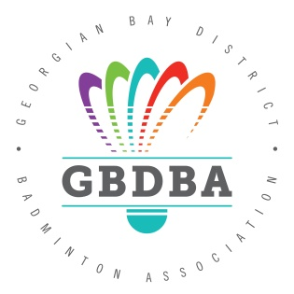
2024 Ontario Winter Games Tryouts

Date: Sunday Oct 22nd, 2023

Location: Barrie North Collegiate Institute 110 Grove St E, Barrie, ON L4M 2P3

Time: 3 pm – 6 pm.
Fee: $25.00 each tryout (exact cash or cheque to GBDBA)
Entry Deadline: Friday October 20th, 2023 – no exceptions
Requirements to try out are as follows:
- Must be 14 – U19 age categories. (Born 2006 or later)
- Living within GBDBA boundaries and/or training at a GBDBA club.

Registration is to be submitted by Oct 20th, 2023 via the online form found here:
https://forms.gle/U7Fh237C6eSjjEwh6

Where are the ONTARIO WINTER GAMES? THUNDER BAY, ON
Dates: Friday February 16 to Monday February 19, 2024
- Please note that Monday the 19th is Family Day
- Participant arrivals occurring on Friday
- Opening Ceremony occurring on Friday
- First official competitions starting on Saturday
- Participant departure occurring on Monday
Email any questions to Mark Martynyshyn
juniorcoordinatorgbdba@gmail.com

